LAB 05 TASK
ROLL NO : 24K-0954
INCLUDE Irvine32.inc

.code
main PROC
; (a) mov AL,7Fh + add AL,1
mov al,7Fh
add al,1
call DumpRegs ; check AL and flags

; (b) mov AL,7Fh - sub AL,80h
mov al,7Fh
sub al,80h
call DumpRegs ; check AL and flags

exit
main ENDP
END main
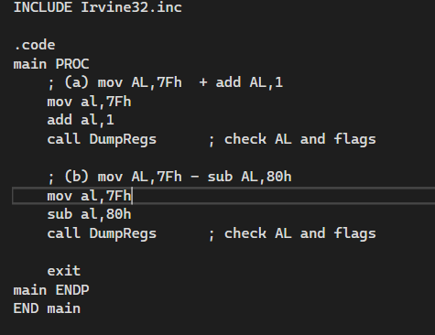
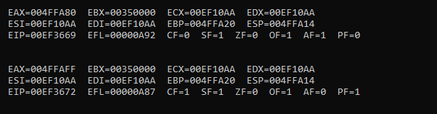
TASK 2
INCLUDE Irvine32.inc

.data
myByte BYTE 12h
myWord WORD 1234h
myDword DWORD 12345678h

.code
main PROC
; (a) OFFSET operator
mov esi, OFFSET myByte
call DumpRegs
mov esi, OFFSET myWord
call DumpRegs
mov esi, OFFSET myDword
call DumpRegs

; (b) PTR operator: high-order word of myDword
mov ax, WORD PTR myDword[2]
call DumpRegs

; (c) TYPE operator
mov bx, TYPE myByte
call DumpRegs
mov bx, TYPE myWord
call DumpRegs
mov bx, TYPE myDword
call DumpRegs

exit
main ENDP
END main
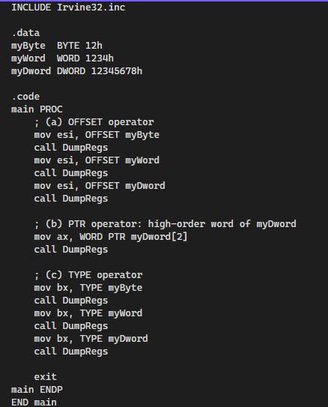
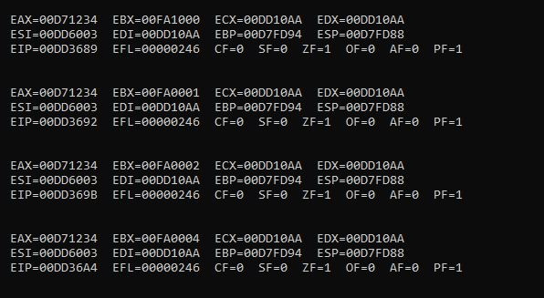

TASK 3
INCLUDE Irvine32.inc

.data
arr1 BYTE 10,20,30,40
arr2 WORD 100h,200h,300h
arr3 DWORD 5 DUP(0)

.code
main PROC
; (a) LENGTHOF examples
mov ax, LENGTHOF arr1 ; 4 elements
mov bx, SIZEOF arr2 ; 6 bytes
mov cx, LENGTHOF arr3 ; 5 elements

; Display results
call DumpRegs

exit
main ENDP
END main
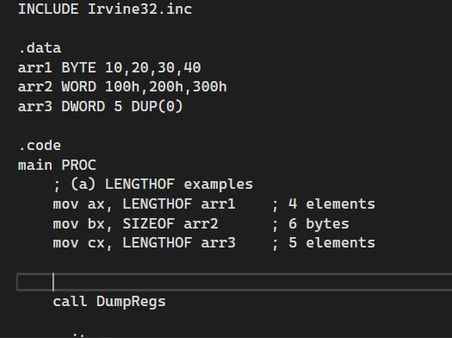
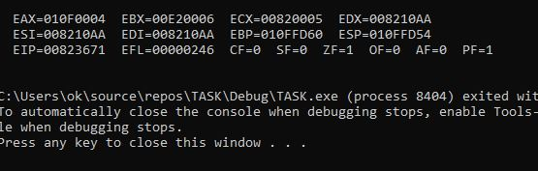

TASK 4
INCLUDE Irvine32.inc
.data
arrayB BYTE 11h,22h,33h
arrayW WORD 4444h,5555h,6666h

.code
main PROC
; (a) BYTE array using indirect addressing
mov esi, OFFSET arrayB
mov ecx, LENGTHOF arrayB
L1:
mov al, [esi]
call WriteHexB ; print byte
call Crlf
inc esi
loop L1

call Crlf

; (b) WORD array using indirect addressing
mov esi, OFFSET arrayW
mov ecx, LENGTHOF arrayW
L2:
mov ax, [esi]
call WriteHex ; print word
call Crlf
add esi, TYPE arrayW ; increment by 2
loop L2

exit
main ENDP
END main
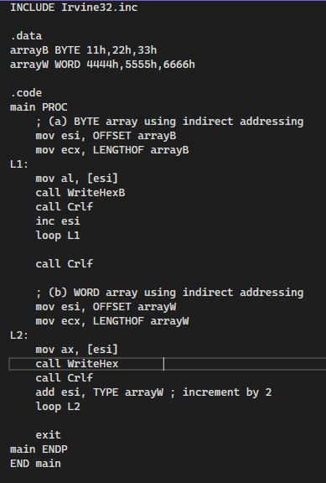
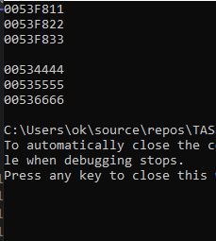
TASK 5
INCLUDE Irvine32.inc
.data
arrayD DWORD 1000h,2000h,3000h,4000h
.code
main PROC
; (a) 2nd element into EAX
mov eax, arrayD[1*TYPE arrayD]
call WriteHex
call Crlf

; (b) last element into EBX
mov ebx, arrayD[3*TYPE arrayD]
call WriteHex
call Crlf

; (c) TYPE operator ensures scaling based on element size (4 for DWORD)
; Without TYPE, index would move by 1 byte instead of 4.
exit
main ENDP
END main
